THE RIVERSIDE PRACTICE
HANDWASHING TECHNIQUES

INTRODUCTION

Effective handwashing techniques are the most important element in the prevention of the spread of infection. The requirements of the National Patient Safety Agency clean hands Alert dated 2nd September 2008 have been incorporated into this document version. This is no longer a current NPSA campaign however the resources are still available in this link.

Further guidance from NICE and NHS Professionals is available via the links at the end of the document.

Hands are a repository for infectious organisms and healthcare staff have the greatest opportunity to transfer these organisms both between patients and between different procedures for the same patient. This is most likely in:

- The transfer of the patient’s own micro organisms into sterile areas of the patient’s body during treatment
- The transfer of micro organisms from one patient to another
- The transfer of micro organisms from the environment and equipment to the patient
- The transfer of micro organisms to yourself and other healthcare staff as a result of patient contact and subsequent person to person contact.

PROCEDURES

The use of an alcohol gel (see below) is usually preceded by handwashing, but may be effective without.

Hands should always be washed:

- When starting work
- When leaving the workplace
- When dirty and also at intervals
- Before and after direct contact with a patient
- After removing gloves
- After visiting the toilet
- After handling soiled items
- Before handling food
- Prior to any clean or aseptic procedure

Other points:

- Always use paper towels (only)
- Never use “bar” soap
- Always ensure that soaps, scrubs, and alcohol gel containers are wall-mounted and dated when opened

- Where nail-brushes are provided these must be single-use sterile brushes, disposed of immediately

Alcohol Gel

The use of alcohol rub should be frequent and routine on non-soiled hands as it is quick, effective, well tolerated by the skin, and can easily be placed in areas where needed the most – for example at the point of patient care, such as treatment rooms, couches, patient chairs etc, as well as adjacent to each clinically–designated sink. It may be used following hand washing, but is also effective on otherwise clean hands where no hand washing facilities are available, and for this purpose a small container may easily be carried in a doctor’s bag.

It may (in addition to the instances above) be used:
- Prior to a patient contact – protect the patient from germs on your hands
- Prior to an aseptic task – protect the patient from germs, including their own, entering the body
- After a body fluid exposure risk – protect yourself and the environment of the room
- After a patient contact - protect yourself and the environment of the room
- After contact with a patient’s surroundings - (e.g. a chair or door handle)

Follow the handwashing technique 6 stage process as illustrated on the poster below where a subsequent sterilisation of hands is required using the gel. Sterilisation is not a substitution for handwashing as gel does not clean hands, however where hand-wash facilities are not available the use of a sterilising gel is appropriate before or after undertaking any of the above activities (e.g. on external visits etc).

Alcohol rub is not the preferred primary hand cleansing product where:
- Hands are visibly soiled
- Patient is experiencing vomiting and / or diarrhoea
- There is direct hand contact with body fluids
- There is an outbreak of norovirus, clostridium difficile or other diarrhoeal illness.

In this case hands should always be washed first with liquid soap and water.
It is recommended that small dispensers (e.g. 125ml) are carried in every doctor’s bag specifically for use on home visits. Wall mounted dispensers should be available above every clinical sink.

Contents should comply with European CEN Standard EN1500.

The poster below should be displayed in the following locations:

- Above every treatment room hand-washing basin
- Above every examination room hand-washing basin
- Above the hand-washing basin in every toilet used by staff

Consideration should also be given to the display of the poster in public toilets. Where possible, the poster should be laminated to facilitate wiping / cleaning.

Handwashing is the single most important activity for preventing cross infection

- Wet hands under running warm water
- Apply liquid soap
- Without applying more water, vigorously rub all parts of the hands using the technique below (20-25 seconds for routine handwashing)
- Rinse hands under running water
- Dry thoroughly using disposable paper towels

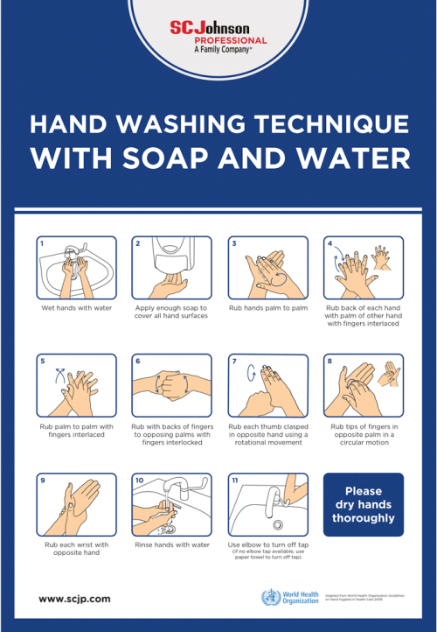

Eleven Step Handwashing Technique

Should supplies of liquid soap or paper towels be needed
please contact Reception

